=Press release=

Sinot Yacht Architecture & Design presents:
AWARE
The Essence of Luxury
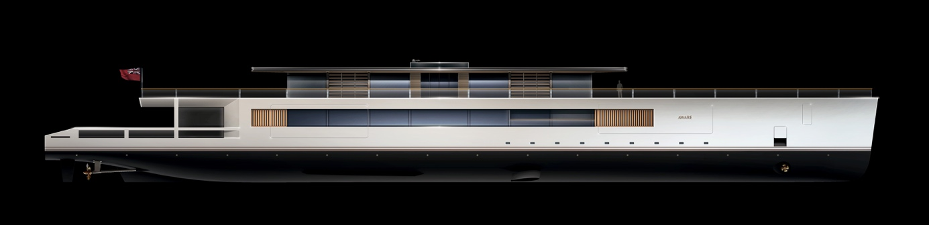
Eemnes / Monaco, September 26, 2023 – Sinot Yacht Architecture & Design is proud to present AWARE, a yacht concept where space optimization is at the forefront and which has an open eye for what matters most: an abundance of space, an exceptional inside-outside connection to the sea, spacious and comfortable lounges, and vast exterior decks. AWARE is the Essence of Luxury, a logical step in yacht design where all the available space is used to give owners and guests the best possible experience. Sinot Yacht Architecture & Design presents the ready to build, fully operational concept AWARE with a stunning 1600 mm scale model at the Monaco Yacht Show 2023 (Stand: Parvis Piscine PP67).
Design Vision AWARE
The world of superyachts is all about optimization: of luxury, of the scarce time owners spend on board with their loved ones, of privacy and of all the delights life at sea has to offer. The optimization of space is at the heart of the design vision for AWARE. As designer Sander Sinot explains: “For the design of AWARE the focus is on maximizing the space on board within the yacht’s limited structure. We designed open plan layouts for the beach club, lounges and exterior decks that offer inherent flexibility and ample space while reducing the number of decks.”
In addition, by reducing GTs, AWARE provides unprecedented amounts of outdoor space on the living areas that are most often used, the beach deck and upper deck, adding the most value for users. “The principle of maximizing space and reducing GT yields with a distinct, sleek, minimalist and super-spacious design that focuses on optimizing a number of much-used larger spaces aboard, is often requested by experienced owners,” Sinot points out. “Other exceptional features are the Beach Club with a 3-meter-high ceiling and fold-down hatches and the sliding parts of the glass façade that seamlessly blends AWARE's interior and exterior.”

The Essence of Luxury
Careful use of proportions in both the exterior and interior of AWARE maximizes exterior and interior serenity resulting in a pure space experience. Light is used as a tool to set interior moods using shutters, adjustable blinds and grids in concealed skylights which admit controlled levels of daylight. Sinot: “For our design team this is one of the most challenging concepts we have ever launched because this is a next step in a yacht’s overall efficiency, and we believe a next step in yacht design.” This efficiency, Sinot stresses, results in the Essence of Luxury: “AWARE combines a superior quality of build with a sophisticated use of natural materials and a seamless integration of technology resulting in a minimalistic, essential design atmosphere that creates a holistic awareness of the yacht for a true connoisseur owner.”
Elongated and elegant
All lounges, interior spaces and exterior decks are proportioned to provide ultimate functionality and an optimal inside-out experience. With a LOA of 79,9 meters and a height of just 8 meters above the waterline, the low profile of AWARE is elongated and elegant. AWARE’s triple deck yacht design has an open plan pavilion on the bridge deck offering unrestricted views of the ocean on all sides.
Owner’s State Room: Dreamtime delights
Located forward on AWARE’s main deck, the beam-wide owner’s state room offers 80m2 of living, sleeping, bathroom and dressing space. Again, optimal use of space provides unprecedented spaciousness. The open plan arrangement combines a bedroom with a lounge and balcony with a private jacuzzi. Glass siding doors and a glass bulwark provide a seamless transition from inside to outside. A combined bathroom and dressing space for the owner’s state room optimizes the efficiency of space usage. All the features in the owner’s state room consist of custom-designed pieces, hand-crafted from durable and natural materials.
Guest State Rooms: Mindful hospitality
AWARE has four beautifully appointed guest state rooms located around AWARE’s central staircase lobby. The full-length windows in the bedrooms and the ensuite bathrooms deliver an infinite connection with the surrounding seascape. The guest state rooms are designed to create an atmosphere of pleasing intimacy and mindful hospitality.
Bridge Deck Pavilion: Free-flowing spaciousness
On the bridge deck, a vast 460m2 exterior deck space surrounds the pavilion for guests to fully enjoy views of the sea. Inside, a lounge, dining area, library, and semi-open wheelhouse are integrated in one free-flowing space of almost 200m2 enclosed by floor-to-ceiling glass facades with adjustable horizontal louvres at the structural mullions. These facades smoothly slide away to unite the dining area with the outdoor lounge seating at the aft of the exterior deck. Skylights with integrated shadow grids are situated in the ceiling along the sides of the pavilion, delivering light into the interior and enforcing the inside-outside connection.
The elegant, central circular staircase connects the lower deck, main deck, and bridge deck onboard. With its sculptural design and position in a glass-covered vide, the stairs seem to float freely in space, creating an impression of monumental weightlessness, emphasizing the staircase’s statement of the pure design language onboard AWARE.
When ascending this grand circular staircase, the oculus in the central lobby lights the route towards the aft lounge, where a seating arrangement of comfortable sofas is situated; the open connection to the aft and side deck exteriors makes dining and lounging a true al-fresco experience.
Semi-open wheelhouse arrangement
The spectacular semi-open wheelhouse’s seating arrangement allows the captain, owner, and travel companions to plan voyages at a large, custom-built round table. The wheelhouse, which encompasses all the latest technologies for the wheelhouse of the future, can be separated from the lounge by closing the sliding doors. This area, crucial for the crew and captain to provide a memorable passage, has been designed for optimal operation with efficient space distribution.
Ready to be build
By launching several high-profile concepts, Sinot has managed to amaze, stimulate, and enthuse its customers and the market over the past decade. Not surprisingly, several concepts that Sinot Yacht Architecture & Design has presented over the years are now in various stages of realization. Like the previously presented concepts, AWARE is ready to be built. The design combines proven technology with exceptional and innovative design elements and the most precious and durable materials. AWARE is the Essence of Luxury, a logical step in yacht design where all available space is used to give the owner and guests the best possible experience. Moreover, the design is such that it lends itself to being completely customized to the wishes of the future owner, without any concession to the uniqueness of this special concept.
Specifications AWARE
Overall length: | 79,9m |  | Performance:
Length waterline: | 79,2m |  | Maximum speed: | 18 knots
Beam moulded: | 12,5m |  | Cruise speed: | 12 knots
Estimated GT: | 1500GT |  | Range: | 4,000 nautical miles at 12 knots
Draught half load: | 3,3m |  | Propulsion: | Diesel-electric

 |  | Tenders and toys:
Guest capacity: | 10 persons  1 Owner’s stateroom,  4 Guest State rooms,  18 Crew + Captain | 10,5m limo tender  8,2m tender  Water toys

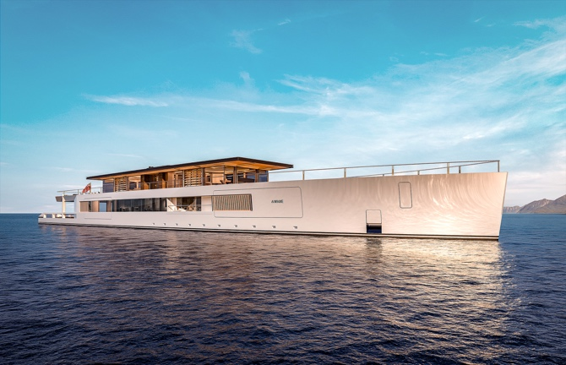  AWARE | 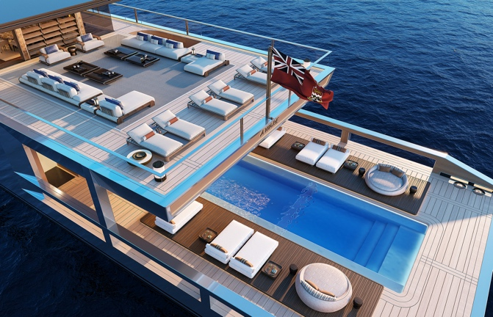  AWARE Exterior BD & MD Pool
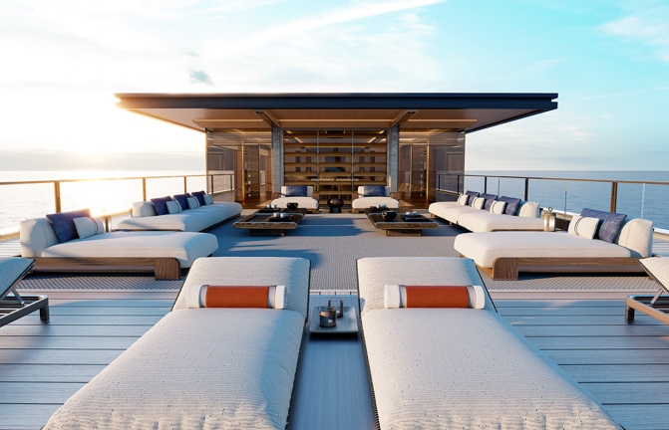  AWARE Aft Deck | 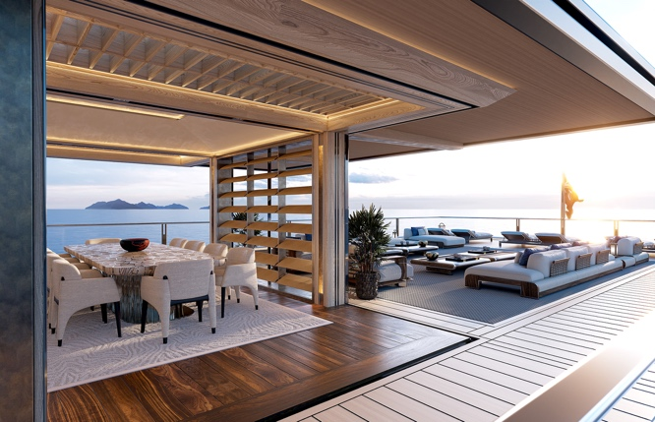  AWARE Dining & Aft Deck
AWARE Beach Club | 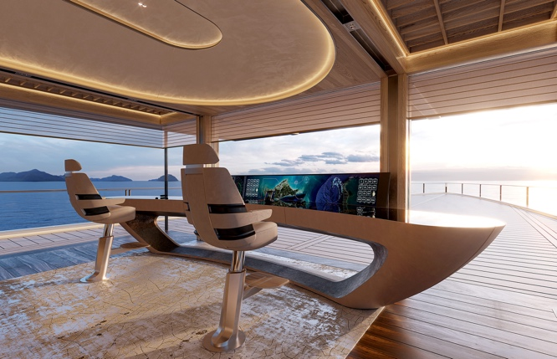  AWARE Wheelhouse

Not for publication
Low-resolution and high-resolution images of Aware can be downloaded directly from our press page: www.mi7.nl/sinot. All images are free for editorial use, please use photo credit: © Sinot Yacht Architecture & Design. For more information on Sinot Yacht Architecture & Design and AWARE during the Monaco Yacht Show 2023, please send an e-mail to: kim@sinot.com. For press enquiries please contact MI7 Media Intelligence, Mischa van de Woestijne, +31 (0)6 2470 42 05, e-mail: mischa@mi7.nl
If you publish an article on Sinot and Aware, we would appreciate it if you could let us know and send a link and or hard copy of the publication to: MI7 Media Intelligence, M. van de Woestijne, Sophialaan 3, 1075BL Amsterdam, The Netherlands.

